Key LLM Models Explained
GPT-4o (OpenAI) – Strong Reasoning

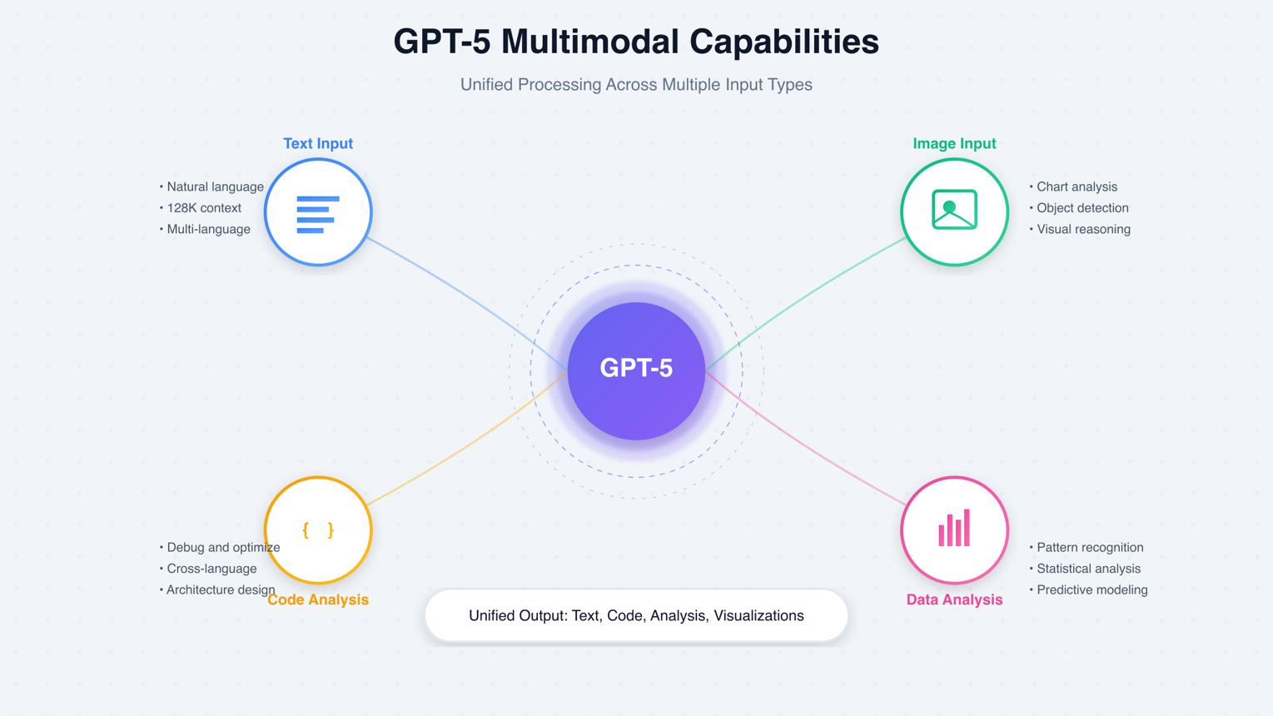
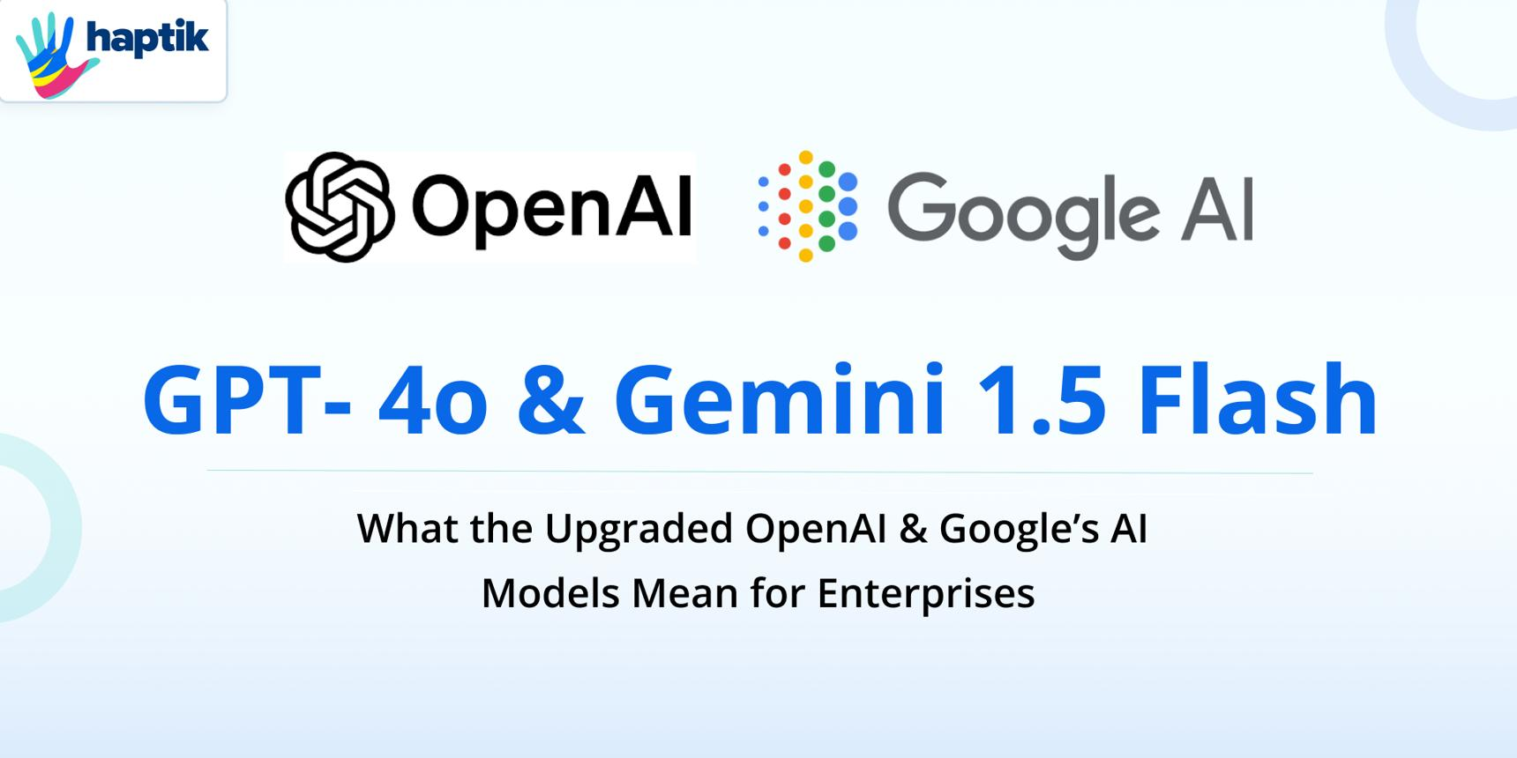
What it’s known for
- Strong logical reasoning
- High-quality code generation
- Fast and efficient responses
Strengths
- Handles complex problems (math, logic, coding)
- Good at structured outputs (JSON, SQL, APIs)
- Multimodal (text, image, audio)
Best use cases
- Application development
- Data engineering tasks
- Automation workflows

Claude 4 (Anthropic) – Safety + Long Context
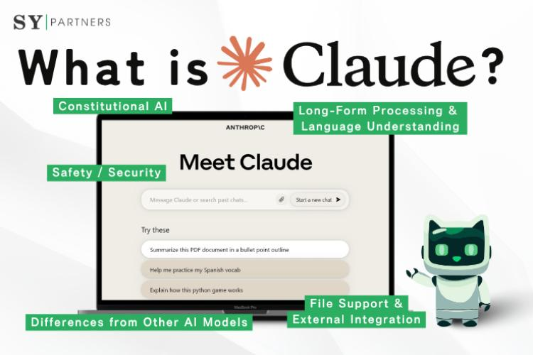
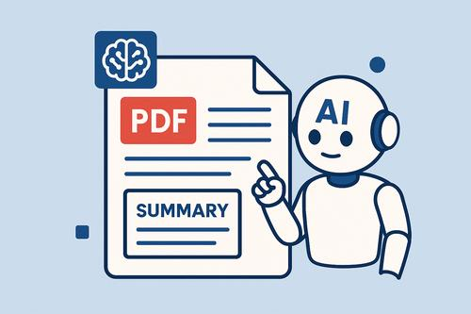
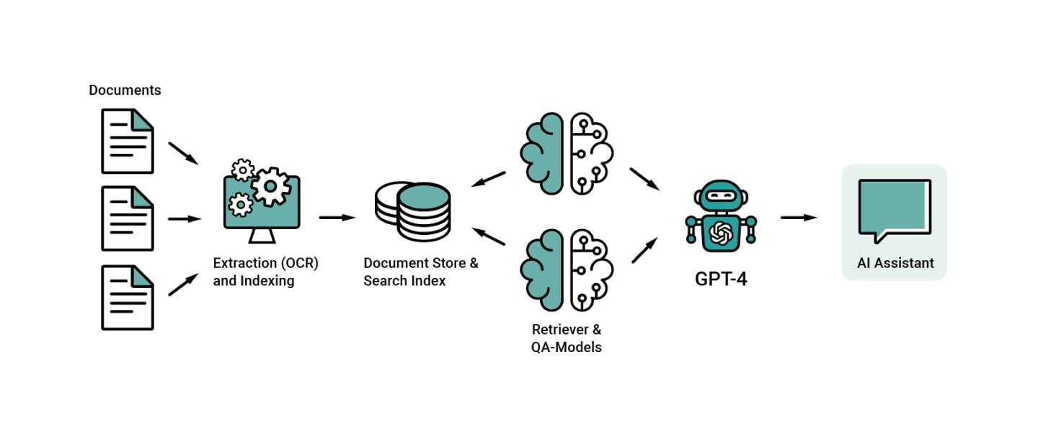
What it’s known for
- Very large context window
- Strong focus on safe and aligned responses
Strengths
- Can process long documents (hundreds of pages)
- Better at avoiding harmful or biased outputs
- Clear and structured explanations
Best use cases
- Document analysis
- Policy and compliance
- Research summarization

Llama 3 (Meta) – Open Source Flexibility
What it’s known for
- Open-source model
- Highly customizable
Strengths
- Can run locally or on private infrastructure
- Fine-tuning possible for domain-specific use
- Cost-effective compared to closed models
Best use cases
- Enterprise private deployments
- Custom AI solutions
- Research and experimentation

Gemini (Google) – Multimodal Power
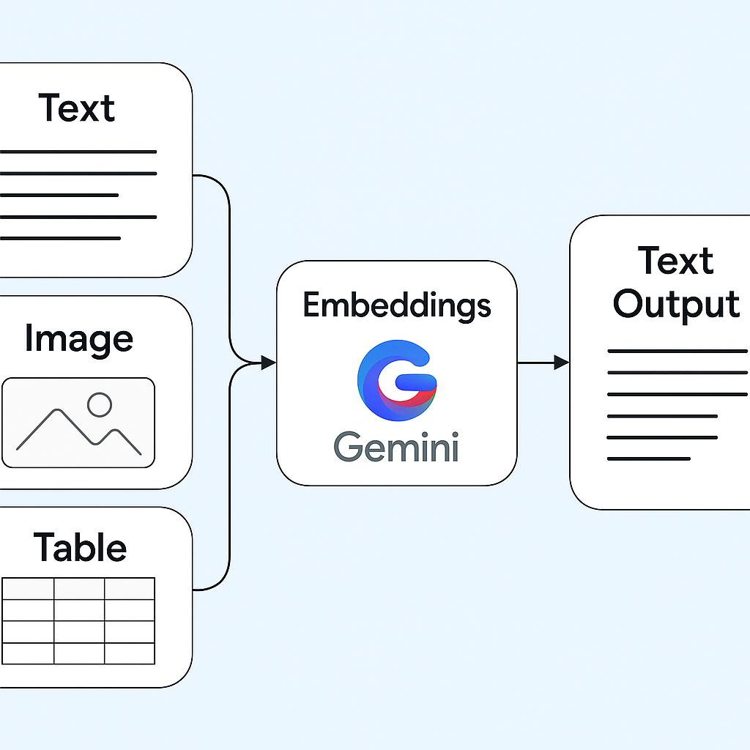
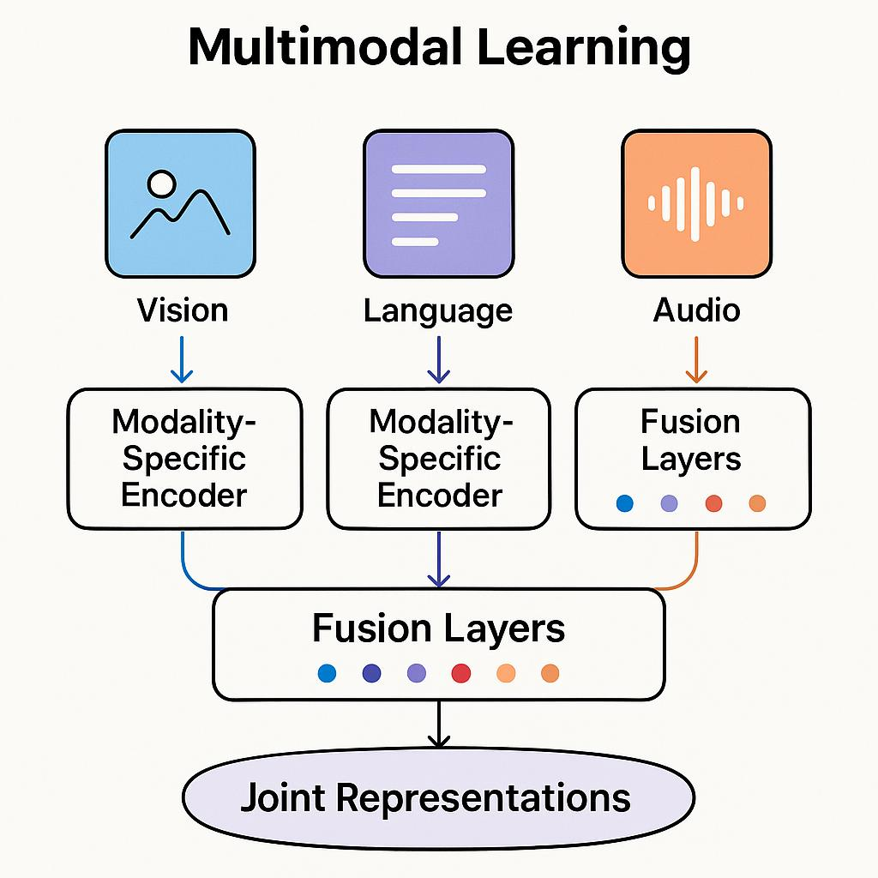
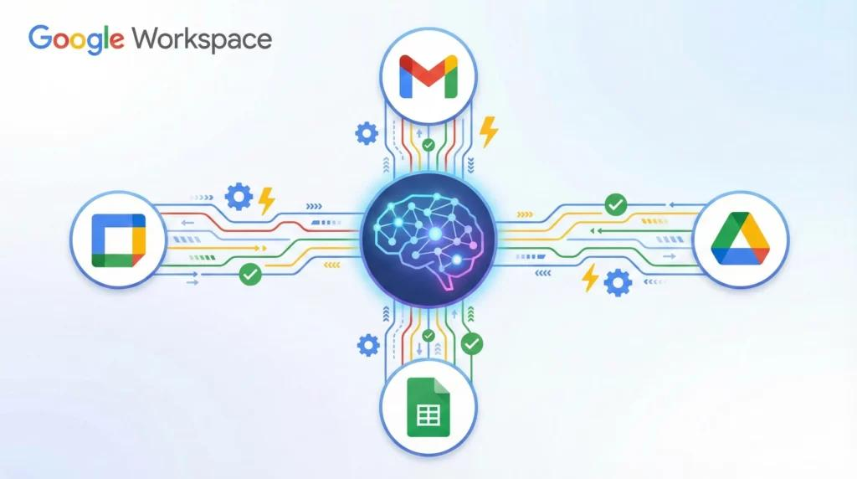
What it’s known for
- Native multimodal capabilities
- Deep integration with Google ecosystem
Strengths
- Handles text, images, audio, video together
- Strong for visual reasoning tasks
- Works well with Google tools (Docs, Sheets, etc.)
Best use cases
- Image/video analysis
- Multimodal applications
- Productivity workflows

Final Comparison Insight
- GPT-4o → Best for reasoning + coding
- Claude → Best for long documents + safety
- Llama → Best for customization + cost control
- Gemini → Best for multimodal tasks

